Education

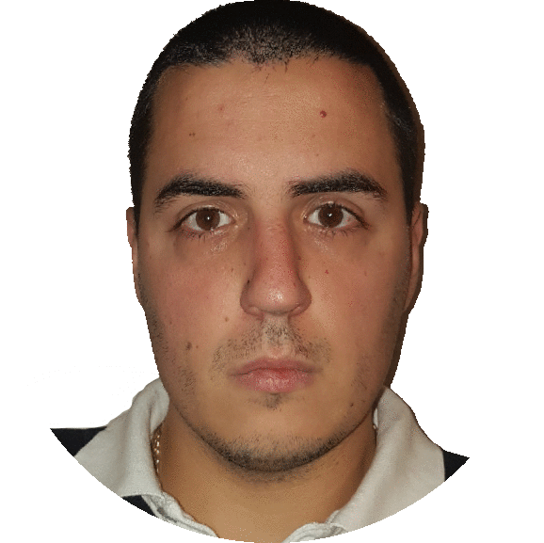

## Graduate at Belgrade Institute of Technology – BIT || **2017**

## Master at Faculty of Technical Sciences Cacak || **2011 -**

## *department: Technics and Informatics*

## Nikola Blagojevic *expect to graduate in 2018.*

## || Web front-end developer ||

## Graduate at Technical School || **2007 - 2011**

## *department: Electrical computer technician*



Skills



 HTML

 CSS

 SASS

 Bootstrap

JavaScript

 jQuery

 React



Other skills







nikolablagojevic@yandex.com



+38169 620 555



https://github.com/Nikolanowi



a_nikola.blagojevic